David L. Suddjian
Biological Consulting Services

801 Monterey Avenue, Capitola, CA 95010
Telephone 831· 479· 9603, email dsuddjian@aol.com

Summary of 2003
Corvid Monitoring Surveys

In The Santa Cruz Mountains

Prepared for

Command Oil Spill Trustee Council
Attn: Steve Hampton
Office of Spill Prevention and Response
California Dept of Fish and Game
PO Box 944209
Sacramento, CA 94244-2090

Prepared by

David L. Suddjian
Biological Consulting Services
801 Monterey Ave., Capitola, CA 95010

May 7, 2004
INTRODUCTION

This report presents the results of corvid monitoring surveys conducted in 2003 for the Command Oil Spill Trustee Council (COSTC) at Big Basin Redwoods State Park, Portola Redwoods State Park, Butano State Park, and San Mateo County Memorial Park (Figure 1). These surveys were commissioned to assist the COSTC in restoration planning for potential projects benefiting the marbled murrelet (Brachyramphus marmoratus), including corvid management.

Corvids have been identified as among the most significant predators on eggs and chicks of marbled murrelets (Nelson 1997). Both Steller’s jay (Cyanocitta stelleri) and common raven (Corvus corax) have been documented to prey on murrelet eggs or chicks in the Santa Cruz Mountains (Singer et al. 1991, Suddjian 2003a, 2003b). The Steller’s Jay has apparently always been a prominent member of the avian community in old growth forests in this region. In contrast, common ravens are relatively new in those forests, and have only become numerous in recent decades (Figure 2; Kelly et al. 2002). Both species are attracted to campgrounds and other areas of parks with high human use, where food is often readily available. Consequently, previous studies and general observations in the Santa Cruz Mountains have typically found both corvids to be much more numerous at campgrounds than away from campgrounds.

This study compares corvid populations in murrelet nesting habitat within campgrounds (treatment areas) to corvid populations in such habitat in areas located >300 meters from campgrounds (control areas). It also provides a baseline from which to judge future changes in numbers related to corvid management projects.

Methods

Study Design

The COSTC requested surveys of Steller’s jay, common raven and American Crow (Corvus brachyrhynchos). However, crows do not presently occur in the parks where this study took place, and so they are not addressed further in this report.

One or more treatment and control areas were established in each park, except at Memorial, where no suitable control areas were identified. Thus, extra control areas were established in Big Basin (those along Gazos Creek Road) to serve as controls for Memorial Park. Five treatment areas and six control areas were selected at Big Basin (Table 1, Figure 3). One treatment area and three control areas were selected at Portola (Table 1, Figure 4). One treatment area and three control areas were selected at Butano (Table 1, Figure 5). Two treatment areas were selected at Memorial (Table 1, Figure 6).

Selection and Description of Survey Areas

The primary criteria for selection of survey areas were that they occur in coast redwood forest known to support use by marbled murrelets, with nesting known or suspected to occur either in or immediately adjacent to the survey area. A secondary criteria was a minimum size of 3.0 hectares, with >5.0 hectares preferred. Since all the campgrounds are located at the bottom of slopes, control areas were selected that were at the bottom of slopes or on side slopes, avoiding ridgelines. Control areas were located along roads or trails to facilitate access.

Treatment areas included standard campgrounds and their immediate surroundings. Group campgrounds were excluded because they are irregularly occupied, and they were often smaller than the minimum size criteria. Two large picnic areas (Opal Creek 1 in Big Basin and Tan Oak Flat in Memorial; Table 1) were also included as treatment areas because of their large size, but other picnic areas were excluded. Control areas were located a minimum of 300 meters from any campground, picnic area, or residential community.

Attributes of each survey area, including size, are given on Table 1.

General Patterns Of Human Use

The campgrounds were used continuously thought the survey period of June to August, although occupancy varied daily and through the season. Occupancy was usually 100% on weekends, and less on weekdays, and was generally greater in July and August than in June. Campground occupancy during the surveys ranged from 23% to 100%, and averaged 38% to 79% (Table 2).

Opal Creek Picnic Area (Opal Creek 1) was used sporadically through the season, mostly on weekends, with only portions of the area open to vehicle access on most days. Tan Oak Flat Picnic Area was used daily. No picnicking occurred in either area during the morning corvid surveys.

Human activity in the control areas was mostly limited to hiking, with no established picnic sites, and there were no people other than the surveyor evident during the morning surveys.

Big Basin Redwoods State Park

Treatment areas included Blooms Creek Campground (55 sites), Sempervirens Campground (31 sites), Huckleberry Campground (71 sites), Wastahi Campground (27 sites), and Opal Creek Picnic Area (Figure 3). Two control areas were located along the upper reach of Opal Creek, and four were along Gazos Creek Escape Road west of Opal Creek (Figure 3).

Campgrounds and the Opal Creek Picnic Area at Big Basin had trash dumpsters with plastic lids, and a small number of metal trashcans with hinged wooden lids. The margins of the plastic lids on the dumpsters were often chewed by squirrels, enabling them to enter and forage, occasionally dragging trash and food out of the dumpster. The lids on the dumpsters and trashcans were usually closed, but rarely left open, and occasionally the lid of overly full dumpster could not be closed, permitting birds and other animals to reach the contents.

Portola Redwoods State Park

The treatment area was the main campground, referred to here as Portola Campground (53 sites; Figure 4). The control areas were along Peters Creek north of the campground, and in two areas along the Iverson Trail (Figure 4).

The campgrounds and picnic areas at Portola had metal trash bins with animal proof lids. No animal access to the cans or spillage around the cans was observed.

Butano State Park

The treatment area was the Ben Ries Campground (62 sites; Figure 5). The control areas were along the Butano Service Road extending northeast from the campground, Goat Hill Trial, and Doe Ridge Trail (Figure 5).

The campground at Butano had metal trashcans with hinged wooden lids, placed within a wooden receptacle. The lids were heavy enough to prevent animal entry, although the edges of some had been partially chewed. No animal access to the cans or spillage around the cans was observed.

San Mateo Memorial County Park

The treatment areas were the Sequoia Flat Campground (104 sites) and the Tan Oak Flat Picnic Area (Figure 6). No control areas with suitable habitat and sufficient distance from areas of high human use were identified, so control areas for this park were located in Big Basin instead (fours areas along Gazos Creek Escape Road, Figure 3).

The campground and picnic area at Memorial had numerous open metal trashcans with no lids, and a small number of metal dumpsters with plastic lids. Eight-six open trashcans were counted in the two Memorial survey areas, and the adjacent (un-surveyed) Azalea Flat and Bay Tree Flat campgrounds. Animal access was commonly observed, and spilled trashcans spilled by raccoons and other mammals were a regular occurrence.

CoRvid Survey Methods

Each area was surveyed using the total area search method (Ralph et al. 1993). The search area at the campgrounds and the picnic area included the entire area of campsites and picnic tables and extended outward 50 meters from the edge of those uses. Control areas were established along roads and trails, and the search area extended outward for 50 meters from the center of the road or trail. Thus, the control areas were equivalent to 100-meter wide strip transects in which the total area searches were conducted. Fifty meters was selected as the outside distance to insure the best chance of detection of perched, silent birds. Vegetation obscured views too significantly beyond 50 meters. Movement was avoided off the road or trail in control areas to minimize noise made by the surveyor.

David Suddjian conducted all the surveys. Surveys were done by walking slowly through the survey area and pausing often for brief periods, listening for vocalizations and making visual scans to detect corvids. Although Luginbuhl et al. (2001) found that broadcasting taped calls enhanced detections of ravens, this method was not used in this study to avoid disturbance of campers. Furthermore, the taped calls might attract ravens into the survey areas from outside the boundary during the survey.

Each jay and raven was recorded, indicating its age if known. Aging of ravens was straightforward though the season due to the status of molt of adults, feather wear, vocalizations, and the presence of a pale gape on the juveniles. Aging of jays was easy in June and most of July (using plumage pattern, begging behavior and vocalizations, and the pale gape of the juveniles), but it became more difficult in late July and August, when the juveniles more closely resembled adults and begging activity declined. Behavior of jays and ravens was recorded in notes, particularly as it related to foraging.

Other information recorded for each survey included date, start and end times, weather conditions, number of occupied campsites, number of opportunities to access human food (i.e., spilled trash, unattended food, campers feeding wildlife), and details of foods consumed by corvids.

Survey Frequency and Timing

Four surveys were conducted in each area, with one survey in June, two in July, and one in August. Survey dates for each site are given on Table 3. Each site was surveyed only once per day, but more than one site was often surveyed on the same day. Campgrounds were only surveyed on weekdays, although one replication at the Big Basin camps occurred on July 4 (a busy camping day, but as it fell on a Friday morning in 2003, the grounds were still not full).

Each survey occurred in a window beginning 35 minutes after sunrise and extending up to four hours after sunrise. The beginning of the morning survey period was based on results of 1,405 dawn surveys that had been conducted previously by Suddjian and colleagues in the Santa Cruz Mountains, where the initial detection of each bird species was recorded each survey (D. Suddjian unpubl. data; Appendix 1). Steller’s Jays typically become active before sunrise (average 15 minutes before sunrise, ±11 minutes, n = 1,386), but ravens usually become active slightly later (average 10 minutes after sunrise, ±26 minutes, n = 769). Thus, the earliest allowable start time was set at the average time in which ravens became active, plus one standard error. This post-sunrise start time also avoided the time before sunrise when jays often exhibit an especially pronounced bout of calling (D. Suddjian pers. obs.), which might bias results if some areas were surveyed then, but others only later in the morning. The end of the survey period, four hours after sunrise, was deemed acceptable after review of results of two years of the Santa Cruz County Forest Bird Monitoring Program, which showed that detections of ravens and jays remained fairly constant through that time (D. Suddjian unpubl. data).

The time required to cover each survey area varied with the size of the area, but the average rate of coverage was 3.1 minute per ha (± 0.6 minute). The time expended in each area was fairly consistent over the four replications.

Analyses

Although the results of surveys at Opal Creek Picnic Area (Opal Creek 1) and Tan Oak Flat Picnic Area are provided in this report, both areas were excluded from analyses comparing treatment and control sites. Neither picnic area was used during the morning survey periods, and human foods were generally not available at that time. Thus, the analyses comparing treatment and control areas were limited to seven total treatment areas (all campgrounds) and 12 control areas.

Analyses comparing treatment and control areas used only the maximum number of corvids detected on any of the four surveys of each area (Luginbuhl et al. 2001), although average counts are also presented in the tables. No effort was made to distinguish among ages of corvids for these analyses. Values of p < 0.05 were considered statistically significant, while values 0.1> p > 0.5 were considered marginally significant.

Results

Steller’s Jay

Survey results and statistical comparisons for each park are given on Tables 4 and 5.
Steller’s jays were recorded in all survey areas, and were detected on all 28 surveys in treatment areas, and 88% of 36 surveys in control areas (Table 4). They were particularly ubiquitous in treatment areas, where overall they were 10.0 times more numerous than in control areas, with the difference being highly significant (Table 5). The higher numbers in treatment areas compared to controls was significant for each park (Table 5). Differences were most pronounced in Memorial (35.5 times greater!) and Big Basin (15.3 times greater), and less but still large at Portola (5.5 times greater) and Butano (4.7 times greater). The difference between parks seems to be due to higher numbers in campgrounds at Memorial and Big Basin, rather than significant differences between control areas in the various parks.

Jay density was positively correlated with the total number of sites in a campground (r = 0.79, p = 0.017; Figure 7), and the number of sites that were occupied during the surveys (r = 0.53, p = 0.002; Figure 8). Sequoia Flat Campground at Memorial consistently had the highest density of jays (maximum raw count of 179 jays on August 20!), exceeding the campgrounds with the next highest densities by two times on two of the four survey replications. This was presumably due to Sequoia Flat’s large size, and especially the numerous open trashcans that permitted easy foraging by jays.

Jays were observed taking advantage of spilled garbage, stealing unattended food in camps, and being fed directly by campers. While such opportunities are available all through the day in campgrounds (D. Suddjian pers. obs.), they were under-represented during the surveys because of the early morning coverage. Most campers were still sleeping or not yet eating at the time the surveys were conducted.

Jays were frequently seen inspecting occupied campsites for food, and were usually very quick to capitalize on any opportunity to steal unattended food. Most campers stored food properly in containers and storage lockers, but improper storage or spilled trash were everyday occurrences in the campgrounds. Sometimes a jay was observed opening plastic bags of chips, nuts, or other food by poking holes through the plastic its bill. Jays also commonly picked at the grills on fire rings and amid the ashes. As a rule they were present to scavenge at the conclusion of meals and the breaking down of camp, when food scraps seemed to be most readily available. They often visited water spigots to drink, or pick scraps of food waste left after people washed dishes. People were seen feeding the jays (and squirrels and chipmunks) everyday in camp, although it was uncommon during the early morning surveys.

Human foods taken by jays during the surveys included: grapes, blueberries, apricots, watermelon, banana, various nuts, chocolate chips, hot dogs, hamburger, beef jerky, bacon, spare ribs, freeze-dried honey-lime chicken, sausage patties, various types of bread, tortillas, muffins, various kinds of chips (Pringles, Tostitos, Fritos, Newmann’s Organic, and BBQ, nacho, chile lime, and sour cream flavored), various kinds of cookies and crackers, marshmallows, cereal, oatmeal.

Jay productivity appeared to be below normal in all of the surveys areas in 2003, and juveniles did not appear until late in the season. Prior surveys in these parks has found fledgling jays as early as early May, with fledglings becoming common in June. In 2003 no juveniles were seen on any of the June surveys, and they remained uncommon until August (Figure 9). Very few juvenile jays were seen in control areas, but that may have been an artifact of small samples of birds of known age in those areas. The seasonal increase in juvenile jays in the campgrounds was statistically significant (r = 0.90, p <0.0001), but no significant increase was evident in the control areas.

Similarly, jay density increased over the season at all campgrounds (r = 0.62, p = 0.002; Figure 10), but densities in control areas showed no consistent pattern among sites. It is likely that the seasonal increase at campgrounds was due to adults and juveniles congregating at those areas, after leaving breeding and natal territories located away from campgrounds.

Common Raven

Survey results and statistical comparisons for each park are given on Tables 6 and 7.
Common ravens were recorded in six of the seven treatment areas (86%; missed only at Wastahi), but only on 54% of 28 surveys in treatment areas. They were detected at just 50% of the 12 control areas, and on only 22% of 36 surveys in control areas (Table 6). Among the treatment areas they were only consistently found at Huckleberry, Portola, and Sequoia Flat. Control areas usually only had ravens detected on just one of the four survey replicates, if at all.

Ravens were generally uncommon. Most surveys recorded only one or two individuals, if any, less frequently three, and rarely four. Overall, they were 2.4 times more numerous at campgrounds than control areas, but the difference was only marginally significant (p = 0.07, Table 7). They were statistically more numerous in campgrounds than in control areas at Portola and Memorial, but not at Big Basin or Butano. However, the absolute differences were small, often due to the presence of a single pair or family group.

Unlike the jays, raven density did not increase over the season. This was likely due to decidedly low productivity in 2003, as several pairs detected in the study areas and elsewhere in the park apparently failed to produce young, or produced just one or two fledglings, rather than the family groups of three or four fledglings that have been commonly observed in the Santa Cruz Mountains over prior years (D. Suddjian pers. obs.).

Ravens were most frequently seen perched, or patrolling along roads and through the campgrounds. They visited open and spilled trashcans at Memorial CP, and were often present where trash was spilled from dumpsters by squirrels at Big Basin. At Memorial a raven was seen eating cake and melted ice cream at a spilled trashcan. They routinely searched through campsites shortly after campers vacated them, but avoided people and handouts. They were not seen pilfering food left briefly unattended, as the jays were quick to do. They did not take the wide variety of human foods eaten by the jays, but seemed to be most interested in obtaining meat.

Discussion And Recommendations

The original survey plan proposed by the COSTC included surveys in May, but these did not occur in 2003 due to delays in contracting. While it would be worthwhile to document corvid numbers in the parks earlier in the breeding season than June, future survey efforts should at least match those of 2003, with four surveys from June to August.

A similar corvid survey program, using the same methods and sampling the same areas, was undertaken in 2002 in these same four parks, sampling in nine treatment areas and 19 control areas (D. Suddjian unpublished data). Overall densities of jays and ravens in 2002 and 2003 are compared on Table 10. Ravens were three times more numerous in 2002 than in 2003, with most of the difference evident in treatment areas. The were continually present in campgrounds during 2002, but more sporadic there in 2003. Raven productivity was much greater in 2002, when all pairs fledged three or four young. Jays were similarly numerous in both years, in both treatment and control areas.

Trash management was best at Portola Redwoods SP with its animal proof trashcan lids, and worst at Memorial County Park with its numerous open trashcans. Behavior of campers was similar in all the parks, and food is essentially continually available at campgrounds. All the parks provide information to campers to encourage them to properly store food and not to feed the wildlife, but this educational effort was generally passive (a posted notice, or asking a camper to initial a short list of regulations upon registration). Food storage was often adequate, but unattended food, handouts, and waste scraps were frequently available. A much more intensive educational program to ensure proper care of trash and food waste, food storage, and to curtail wildlife feeding should be developed and implemented. Such a program should educate park users about the link between human food, corvid numbers, and predation on endangered marbled murrelets. An educational program should be sure to target parents and their children, as much of the available food scraps are scattered or offered by children.

However, even an intensive program may not be effective at substantially limiting opportunities for corvids to obtain human food in campgrounds. It will difficult to effectively eliminate anthropogenic foraging opportunities in any area where large numbers of people eat meals outdoors. This is especially true for corvids because even small food fragments and scraps attract them. Permanent or seasonal campground closure in murrelet habitat many be more effective at reducing corvid numbers and predation than park user education programs, but the later should certainly be developed and employed.

Literature Cited

Kelly, J. P., K. L. Etienne and J. E. Roth. 2002. Abundance and distribution of the common raven and American crow in the San Francisco Bay Area, California. West. Birds 33:202-217.

Luginbuhl, J. M., J. M. Marzluff, J. E. Bradley, M. G. Raphael, and D. E. Varland. 2001. Corvid survey techniques and the relationship between corvid relative abundance and nest predation. Journal of Field Ornithology 72:556-572.

Nelson, S. K. 1997. Marbled Murrelet (Brachyramphus marmoratus). No. 276 in The birds of North America (A. Poole and F. Gill, Eds.) Acad. Of Nat. Sci., Philadelphia, Pennsylvania, and the Amer. Orn. Union, Washington D.C.

Ralph, C. J., Geupel, G. R., Pyle, P., Martin T. E. and D. F. DeSante. 1993. Handbook of field methods for monitoring landbirds. Gen. Tech. Rep. PSW-GTR-144. Pac. Southwest Res. Station, Forest Service, U.S.D.A.

Singer, S. W., Naslund, N. L., Singer, S. A., and C. J. Ralph. 1991. Discovery and observation of two tree nests of the Marbled Murrelet. Condor 93: 330-339.

Suddjian, D. L. 2003a. Summary of 2002 Marbled Murrelet monitoring surveys
at Big Basin and Portola State Parks. Unpubl. report. Prepared for the California Dept. of Fish and Game.

Suddjian, D. L. 2003b. 10 Years of monitoring Marbled Murrelets at the South Fork of Butano Creek, San Mateo County, California, 1992-2001. Unpubl., report prepared for Big Creek Lumber Company.
Table 1. Attributes of the corvid survey areas.

Human Area Slope Approx. Canopy Composition³

Survey Area Type Use Access¹ (ha) Position² Elevation RW DF TO ILO MA Other

Big Basin Redwoods SP
Blooms Creek Treatment Camp 1 15.7 B 900–1,120’ 1 2 1 2 3 3
Sempervirens Treatment Camp 1 7.2 B 960-1,080’ 1 2 1 2 3 --
Huckleberry Treatment Camp 1,2 13.4 B 980-1,160’ 1 2 1 1 2 --
Wastahi Treatment Camp 1,3 7.2 B 1,020-1,250’ 1 2 1 -- -- --
Opal Creek 1 Treatment Picnic 1 24.1 B 950-1,180’ 1 2 1 2 3 3
Opal Creek 2 Control Hiking 1 10.2 B 1,050-1,180’ 1 2 1 3 3 3
Opal Creek 3 Control Hiking 3 6.6 B 1,075-1,225’ 1 2 1 3 3 3
Gazos Creek Road 1 Control Hiking 2 9.4 S 1,120-1,280’ 1 2 1 2 2 --
Gazos Creek Road 2 Control Hiking 2 6.7 S 1,240-1,350’ 1 1 1 2 2 --
Gazos Creek Road 3 Control Hiking 2 7.5 S 1,140-1,320’ 1 2 1 2 2 --
Gazos Creek Road 4 Control Hiking 2 7.5 S 960-1,180’ 1 2 1 2 2 --

Portola Redwoods SP
Portola Treatment Camp 1 8.4 B 350-560’ 1 2 1 1 3 3
Peters Creek Control Hiking 1,3 7.7 B 400-600’ 1 2 1 2 3 3
Iverson Trail 1 Control Hiking 3 7.1 B 320-520’ 1 2 1 2 2 3
Iverson Trail 2 Control Hiking 2,3 6.9 B 350-520’ 1 2 1 3 3 3

Continued on next page,

Table 1, continued

Human Area Slope Approx. Canopy Composition³

Survey Area Type Use Access¹ (ha) Position² Elevation RW DF TO ILO MA Other

Butano SP
Ben Ries Treatment Camp 1,3 9.6 B 400-650’ 1 2 1 3 3 --
Butano Service Road Control Hiking 2 8.1 B 500-670’ 1 2 1 3 3 3
Goat Hill Trail Control Hiking 3 3.2 S 620-840’ 1 2 1 2 3 --
Doe Ridge Trail Control Hiking 3 15.7 S 880-1,120’ 1 1 1 2 3 --

Memorial CP
Sequoia Flat Treatment Camp 1 12.6 B 180-280’ 1 2 1 2 -- 2
Tan Oak Flat Treatment Picnic 1 7.9 B 200-280’ 1 2 2 1 3 3

1. Access: 1 (paved road), 2 (unpaved road), 3 (trail).
2. Slope position: B (bottom of valley), S (mid-slope), R (ridgeline).
3. Approximate canopy cover by each tree species, classed as 1 (50-100%), 2 (11-49%), 3 (1-10%). Tree species: RW (coast redwood), DF (Douglas-fir), TO (tan oak), ILO (interior live oak), MA (madrone), other (includes California bay, red alder, white alder, and big leaf maple)
Table 2. Campground occupancy during the 2003 corvid surveys.

Survey Area
# Sites
Run 1
Run 2
Run 3
Run 4
Avg

Big Basin Redwoods SP

Blooms
55
73%
76%
80%
69%
75%

Sempervirens
31
61%
87%
94%
74%
79%

Huckleberry
71
54%
86%
55%
70%
66%

Wastahi
27
22%
67%
26%
56%
43%

Portola Redwoods SP

Portola
53
25%
83%
47%
23%
44%

Butano SP

Ben Ries
61
23%
30%
62%
36%
38%

Memorial CP

Sequoia
104
25%
42%
100%
46%
53%

Table 3. Dates of the 2003 corvid surveys.

Survey Dates

Survey Area Run 1 Run2 Run 3 Run 4

Big Basin Redwoods SP
Blooms Creek June 18 July 4 July 18 August 21
Sempervirens June 18 July 4 July 18 August 21
Huckleberry June 18 July 4 July 18 August 21
Wastahi June 18 July 4 July 18 August 21
Opal Creek 1 June 20 July 5 July 16 August 19
Opal Creek 2 June 20 July 5 July 16 August 19
Opal Creek 3 June 20 July 5 July 16 August 19
Gazos Creek Road 1 June 19 July 3 July 17 August 17
Gazos Creek Road 2 June 19 July 3 July 17 August 17
Gazos Creek Road 3 June 19 July 3 July 17 August 17
Gazos Creek Road 4 June 19 July 3 July 17 August 17

Portola Redwoods SP
Portola June 25 July 10 July 28 August 26
Peters Creek June 25 July 10 July 28 August 26
Iverson Trail 1 June 24 July 11 July 29 August 26
Iverson Trail 2 June 24 July 11 July 29 August 26

Butano SP
Ben Ries June 10 July 1 July 22 August 8
Butano Service Road June 11 July 2 July 21 August 7
Goat Hill Trail June 11 July 2 July 21 August 7
Doe Ridge Trail June 11 July 2 July 21 August 7

Memorial CP
Sequoia Flat June 12 July 8 July 25 August 20
Tan Oak Flat June 12 July 8 July 25 August 20

Table 4. Number of Steller’s jays per hectare on the 2003 surveys.

Survey Area | Run 1 |  | Run 2 |  | Run 3 |  | Run 4 |  | Max |  | Avg

Big Basin Redwoods SP
Blooms | 1.59 |  | 2.99 |  | 3.63 |  | 5.92 |  | 5.92 |  | 3.54
Sempervirens | 1.53 |  | 3.47 |  | 4.58 |  | 7.50 |  | 7.50 |  | 4.27
Huckleberry | 3.06 |  | 3.36 |  | 3.58 |  | 7.61 |  | 7.61 |  | 4.40
Wastahi | 1.39 |  | 0.28 |  | 0.56 |  | 3.19 |  | 3.19 |  | 1.35
Opal 1 | 0.71 |  | 0.50 |  | 0.21 |  | 0.87 |  | 0.87 |  | 0.57
Opal 2 | 0.29 |  | 0.29 |  | 0.20 |  | 0.10 |  | 0.29 |  | 0.22
Opal 3 | 0.61 |  | 0.00 |  | 0.30 |  | 0.00 |  | 0.61 |  | 0.23
Gazos 1 | 0.43 |  | 0.43 |  | 0.32 |  | 0.11 |  | 0.43 |  | 0.32
Gazos 2 | 0.00 |  | 0.30 |  | 0.30 |  | 0.15 |  | 0.30 |  | 0.19
Gazos 3 | 0.13 |  | 0.53 |  | 0.40 |  | 0.00 |  | 0.53 |  | 0.27
Gazos 4 | 0.40 |  | 0.27 |  | 0.27 |  | 0.40 |  | 0.40 |  | 0.33
Portola Redwoods SP
Portola | 0.83 |  | 2.86 |  | 2.86 |  | 4.40 |  | 4.40 |  | 2.74
Peters | 0.39 |  | 0.52 |  | 0.39 |  | 0.39 |  | 0.52 |  | 0.42
Iverson 1 | 1.13 |  | 0.70 |  | 0.85 |  | 0.85 |  | 1.13 |  | 0.88
Iverson 2 | 0.43 |  | 0.29 |  | 0.72 |  | 0.29 |  | 0.72 |  | 0.43
Butano SP
Ben Ries | 2.29 |  | 3.33 |  | 3.65 |  | 4.69 |  | 4.69 |  | 3.49
Service | 0.49 |  | 0.99 |  | 0.37 |  | 0.49 |  | 0.99 |  | 0.59
Goat Hill | 1.25 |  | 0.94 |  | 0.63 |  | 0.94 |  | 1.25 |  | 0.94
Doe Ridge | 0.38 |  | 0.76 |  | 0.32 |  | 0.32 |  | 0.76 |  | 0.45
Memorial CP
Sequoia | 3.65 |  | 5.63 |  | 8.49 |  | 14.21 |  | 14.21 |  | 8.00
Tan Oak | 1.39 |  | 1.01 |  | 1.90 |  | 0.89 |  | 1.90 |  | 1.30

Table 5. Comparison of numbers of Steller’s jays between treatment and control areas.

Statistical
Survey Area Avg/ha¹ S.E. N Significance

All parks combined
Treatment 6.8 3.7 7 t = 5.9, p^{(1-tailed)} < 0.0001
Control 0.7 0.3 12

Big Basin Redwoods SP
Treatment 6.1 2.1 4 t = 3.4, p^{(1-tailed)} = 0.004
Control 0.4 0.1 6

Portola Redwoods SP
Treatment 4.4 0.0 1 t = 10.1, p^{(1-tailed)} = 0.005
Control 0.8 0.3 3

Butano SP
Treatment 4.7 0.0 1 t = 13.0, p^{(1-tailed)} = 0.002
Control 1.0 0.2 3

Memorial CP
Treatment 14.2 0.0 1 t = 130, p^{(1-tailed)} <0.0001
Control² 0.4 0.1 4 ²see note

- Average of maximum counts from each survey area.
2. Controls for Memorial CP were located in Big Basin Redwoods SP.

Table 6. Number of common ravens per hectare on the 2003 surveys.

Survey Area | Run 1 | Run 2 | Run 3 | Run 4 | Max | Avg
Big Basin Redwoods SP
Blooms | 0.19 | 0.19 | 0.00 | 0.00 | 0.19 | 0.10
Sempervirens | 0.14 | 0.00 | 0.00 | 0.00 | 0.14 | 0.03
Huckleberry | 0.22 | 0.22 | 0.22 | 0.22 | 0.22 | 0.22
Wastahi | 0.00 | 0.00 | 0.00 | 0.00 | 0.00 | 0.00
Opal 1 | 0.17 | 0.12 | 0.12 | 0.04 | 0.17 | 0.11
Opal 2 | 0.00 | 0.00 | 0.10 | 0.00 | 0.10 | 0.02
Opal 3 | 0.00 | 0.45 | 0.00 | 0.00 | 0.45 | 0.11
Gazos 1 | 0.00 | 0.00 | 0.00 | 0.00 | 0.00 | 0.00
Gazos 2 | 0.00 | 0.00 | 0.00 | 0.00 | 0.00 | 0.00
Gazos 3 | 0.00 | 0.13 | 0.13 | 0.00 | 0.13 | 0.07
Gazos 4 | 0.00 | 0.00 | 0.00 | 0.00 | 0.00 | 0.00
Portola Redwoods SP
Portola | 0.00 | 0.48 | 0.36 | 0.36 | 0.48 | 0.30
Peters | 0.00 | 0.13 | 0.00 | 0.00 | 0.13 | 0.03
Iverson 1 | 0.00 | 0.00 | 0.14 | 0.00 | 0.14 | 0.04
Iverson 2 | 0.00 | 0.00 | 0.00 | 0.00 | 0.00 | 0.00
Butano SP
Ben Ries | 0.10 | 0.00 | 0.00 | 0.10 | 0.10 | 0.05
Service | 0.12 | 0.12 | 0.00 | 0.00 | 0.12 | 0.06
Goat Hill | 0.00 | 0.00 | 0.00 | 0.00 | 0.00 | 0.00
Doe Ridge | 0.00 | 0.00 | 0.00 | 0.00 | 0.00 | 0.00
Memorial CP
Sequoia | 0.16 | 0.24 | 0.32 | 0.40 | 0.40 | 0.28
Tan Oak | 0.25 | 0.38 | 0.25 | 0.25 | 0.38 | 0.28

Table 7. Comparison of numbers of Steller’s jays between treatment and control areas.

Statistical
Survey Area Avg/ha¹ S.E. N Significance

All parks combined
Treatment 0.22 0.16 7 t = 1.9, p^{(1-tailed)} = 0.077
Control 0.09 0.14 12

Big Basin Redwoods SP
Treatment 0.14 0.10 4 t = 0.4, p^{(1-tailed)} = 0.968
Control 0.11 0.18 6

Portola Redwoods SP
Treatment 0.48 0.0 1 t = 4.3, p^{(1-tailed)} = 0.025
Control 0.09 0.08 3

Butano SP
Treatment 0.1 0.0 1 t = 0.8, p^{(1-tailed)} = 0.266
Control 0.04 0.07 3

Memorial CP
Treatment 0.4 0.0 1 t = 15.6, p^{(1-tailed)} <0.007
Control² 0.03 0.07 4 ²see note

- Average of maximum counts from each survey area.
- Controls for Memorial CP were located in Big Basin Redwoods SP.

Table 8. Number of corvids per hectare in treatment and control areas on similar corvid surveys in the four parks in 2002 and 2003¹.

Species 2002 2003

Steller’s Jay
Treatment areas 5.4 ± 1.5 6.8 ± 3.7
Control areas 0.6 ± 0.3 0.7 ± 0.3

Common Raven
Treatment areas 0.6 ± 0.1 0.2 ± 0.2
Control Areas 0.1 ± 0.1 0.1 ± 0.1

- D. Suddjian unpublished data
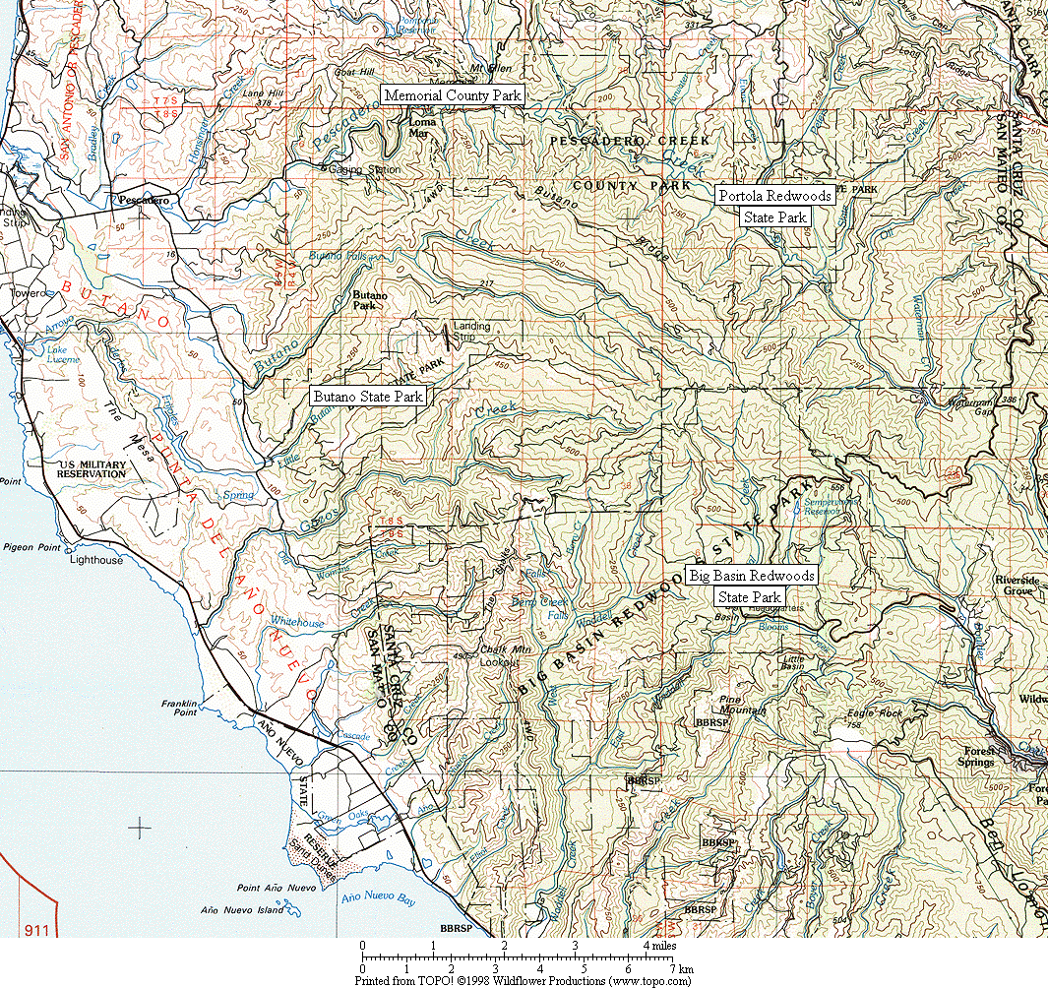

Figure 1. General location of survey areas.

Figure 2. Common Ravens have increased dramatically in all six Christmas Bird Count circles in the Santa Cruz Mountains region.
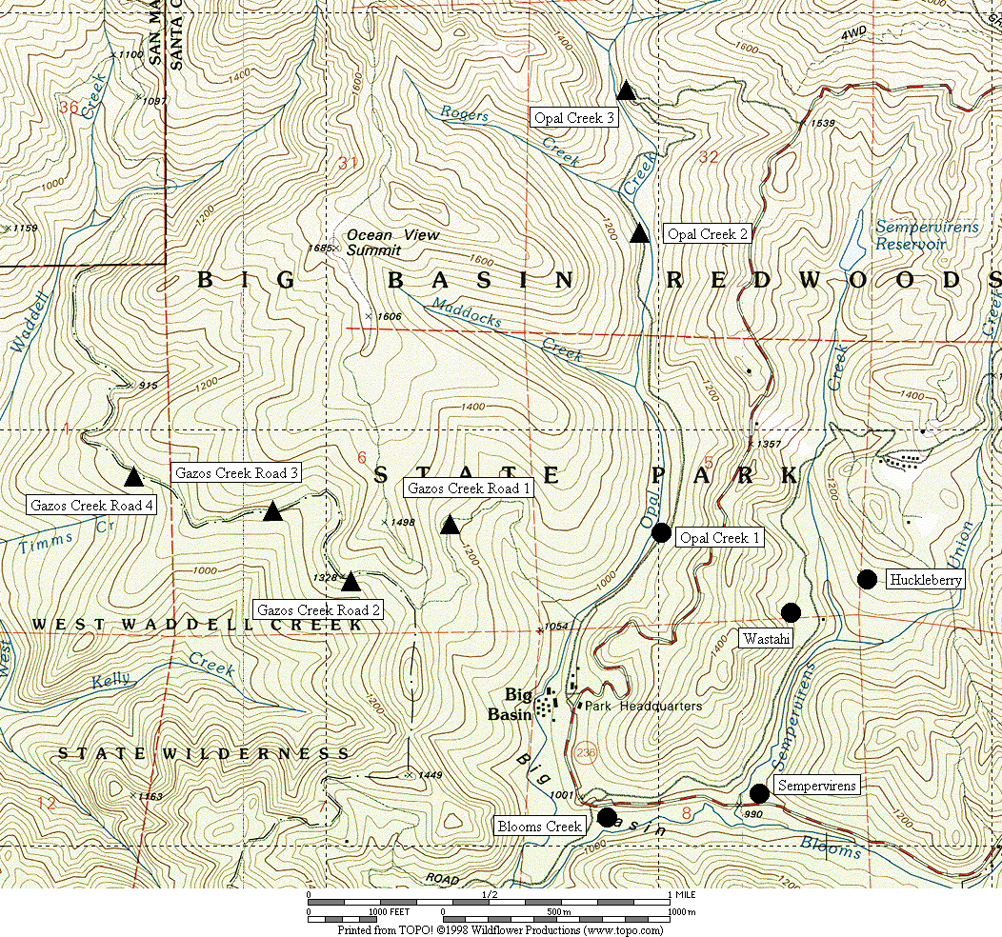

Figure 3. General location of corvid surveys area at Big Basin Redwoods State Park.
● treatment sites ▲ control sites

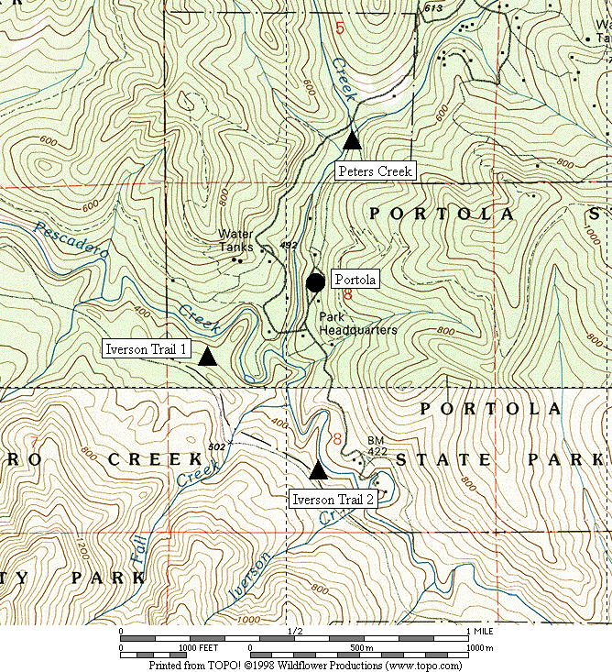

Figure 4. General location of corvid surveys area at Portola Redwoods State Park.
● treatment sites ▲ control sites

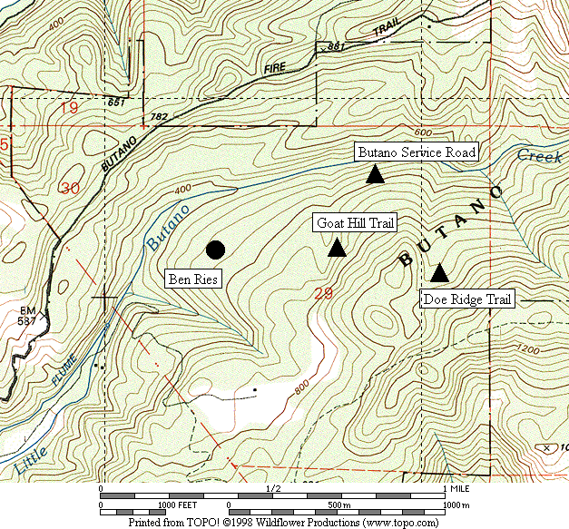

Figure 5. General location of corvid surveys area at Butano State Park.
● treatment sites ▲ control sites

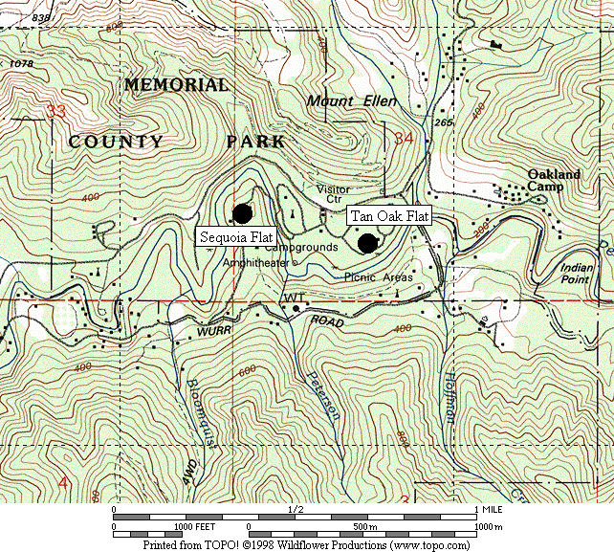

Figure 6. General location of corvid surveys area at San Mateo County Memorial Park.
● treatment sites

Figure 7. Jay density was positively correlated with the total number of sites in a campground.

Figure 8. Jay density was positively correlated with the number of occupied campsites.

Figure 9. Juvenile jays were absent in June, and did not become numerous until August. (Note - on the X-axis: 1 = June 1, 20 = June 20, 40 = July 10, 60 = July 30, 80 = August 19)

Figure 10. The density of jays increased over the season in campgrounds.
(Note - on the X-axis: 1 = June 1, 20 = June 20, 40 = July 10, 60 = July 30, 80 = August 19)
Appendix 1
Time of first detectable activity by Steller’s jay and common raven
in the Santa Cruz Mountains.

Times of first detection of jays and ravens were recorded on 1,405 dawn surveys in forest habitats of the Santa Cruz Mountains (D. Suddjian unpubl. data).

Figure 1. The average time of first detection for Steller’s jay was 15 minutes before sunrise (±11 minutes, n = 1,386).

Figure 2. The average time of first detection for common raven was 10 minutes after sunrise (±26 minutes, n = 769).

